PROJECT BRIEF – BENGA ENGINEERING E-MOBILITY PROJECT

Table of Contents

Abréviations 2

Introduction 3

Project Scope – 5

Project Location 5

**Table 1 :** **Project location profile** 5

Trends in the E-MOBILITY 6

Trends in the E-MOBILITY 6

Electric Vehicles Categories 8

Swapp Battery Swapping Network – Kiosks (Solar Paneled Roofs Ing Network 8

Table 3 : Swapp Battery Demand 8

Swapp Battery Swapping Network 9

Electricity Demand for e-Mobility 9

Battery Swapping Network: Questions most asked 10

Contents 11

Global trends 11

E-mobility Development impact in the light of SDG (Sustainable Development Goals) 13

Investment opportunities – (Financial options) 14

Market Overview 15

Comparison with 1300cc less vehicles (new & used) (Taxation, 15

E-mobility opportunities in Kenya 15

Country Economic Indicators 17

Market Challenges 17

Business Model 17

Business Model construcrs 17

Business Model 18

Industry and Market Analysis 19

Value Chain Analysis 19

P5Fs(Porter five force) 21

SWOT Analysis Su 22

Market Strategy (Local) 23

: Market Demand 24

Competitive analysais 24

Do we have electric motor vehicles in Kenya? 24

Marketing strategy 25

Customer Segmentation 26

Integrated Marketing Strategy 27

Online Marketing Plan 27

Product and product differentiation 27

Channel Strategy 27

Brand 27

Branding 27

Budgeting 27

Revenues 27

Sales 27

Profitability analysis. 27

Valuation: 27

Pricing Strategy 28

Supply and Demand 31

Environmental impact 31

Conclusion 32

# Abréviations

EV ; Electric vehicle

SDOT : [State Department of Transport and Infrastructure](https://transport.go.ke/department/)

# Introduction

Africa finds itself at a crossroads in terms of mobility – on the one hand, the continent still has one of the lowest motorization levels in the world; on the other hand, the continent is facing one of the fastest vehicle growth rates. Annual vehicle sales are increasing rapidly, at over 10% in most African countries compared to 4% in European countries.

A large proportion of vehicles are second-hand, and only 1 in 10 vehicles imported into the region is new. This presents a unique opportunity for African countries to improve the emission of their vehicle fleet before motorization further takes off. Sub-Saharan Africa (SSA), in particular, is undergoing a mobility revolution spurred by rapid urbanization, rising population numbers, growing energy demand, and economic growth. This comes at a time when most African countries are already grappling with mobility challenges in terms of congestion, inadequate infrastructure, air pollution, health issues, and the fiscal burden high fuel prizes and subsidies place on the economy.²Vehicles powered by electricity and running on battery storage offer a fantastic solution to the above problems.

# Kenyan Market

Some commonalities are to be observed in terms of the modal split, characterized by

high shares of collective transport and walking, and of the evolution of urban transportation

systems in the last decades.

* In Nairobi, walking, informal private minibuses acting de factors public transport (matatus) and semi-formal buses are the dominant mobility options, with, respectively, 39.7%, 28.5% and 12.2% of the modal share in 2013
* While Kisumu lacks a formal public transport system, moto-bodas (13.5%) and matatus/buses (13%) are ,apart from walking (52.7%), the dominant form of transportation [29]. Similarly, in Dares Salaam, 62% of trips happened with daladalas (minibuses), 17% with walking and 12%with private vehicles in 2014
* In Kigali, the majority of trips are made on foot or Sustainability 2021, 13, 1703 7 of 21bike (52%) or by public transport (PT), mostly bus services (16%), but also motorcycle taxis (12%). The city is also characterized by low to moderate levels of motorization(approximately 15 automobiles for every 1000 inhabitants)
* . Each of the cities initiated important investment into public transportation to various degrees, except for the caseo f Kisumu which is still planning to undertake a scoping study for a potential public transport project

# Project Scope –

1. 2 Wheels electric motorcycle
2. 3-Wheeler Cargo
3. 3-Wheeler Passenger
4. Battery Swapping Network – Kiosks (Solar Paneled Roofs)

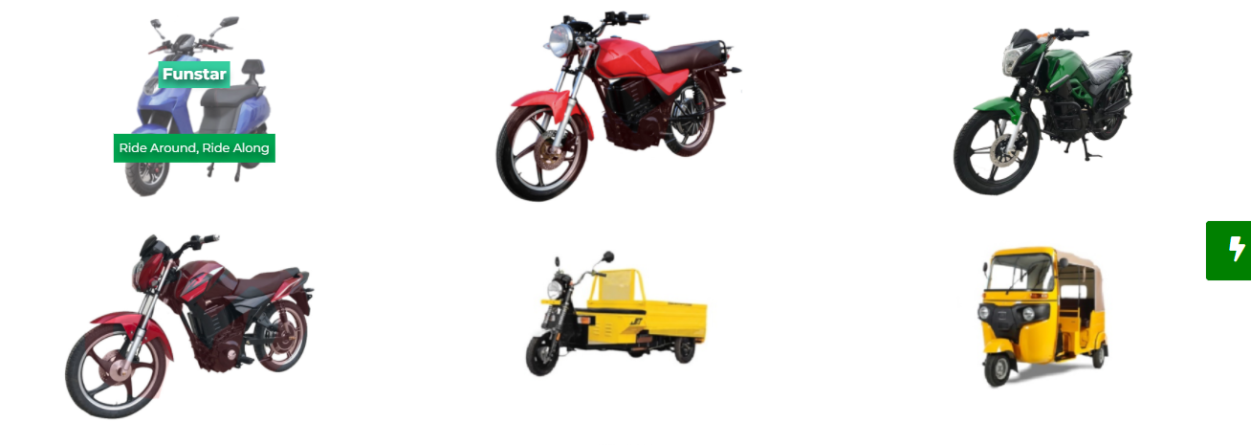

Figure 1:1,2,3:EV shows various models captured in this project scope,

## Project Location

## **Table 1 :** **Project location profile**

|  |  |
| --- | --- |
| Project location | |
| Politics | Constitutional Democracy |
| Population | 50 ,0000 Million |
| Geography | E Africa |
| Major Languages | English ,Swahili |
| Currency | KSHS |
| Economic Activity (Commodity Based) | Agriculture, Export, Industry, Natural Resource ,tourism |
| GDP | 3TR |

## Trends in the E-MOBILITY

Trends in the E-MOBILITY sector that any investo r/stakeholder should be wary of

Table 2 : Trends in the E-MOBILITY

|  |  |
| --- | --- |
| Trends in the E-MOBILITY | |
| Growth |  |
| Growth | * Africa annual vehicle Sales Are Increasing Rapidly ;10% * Europe Annual Growth 4% * The Number Of EV Models Is Rising, With 400+ New Models Expected By 2025 |
| Market demographics | * more than 60% of Sub-SaharanAfricans are living outside of urban areas * 80% of African urban dwellers do not own a motor vehicle * more than 650 million people,walk, bike or use public transport |
| Sales | * 2021 was a landmark year with global electric plug-in sales **increasing**[**108%**](https://cleantechnica.com/2022/01/30/world-ev-sales-tesla-model-3-wins-4th-consecutive-best-seller-title-in-record-year/)from [**3.24m**](https://seekingalpha.com/article/4403081-ev-company-news-for-month-of-january-2021?gclid=Cj0KCQiAi9mPBhCJARIsAHchl1wvAu6jXbq7VML12_9jwooSf07WlVoGtrGZWSQkQ26RF9MDYKKVm3YaAn5nEALw_wcB&source=content_type%3Areact%7Csection%3Amain_content%7Cbutton%3Abody_link&utm_campaign=14823831578&utm_medium=cpc&utm_source=google&utm_term=128719140158%5Eaud-830997688245%3Adsa-1427141793820%5E%5E549166468495%5E%5E%5Eg) in 2020 (~4.2% market share) to [**6.75m**](https://www.ev-volumes.com/) **in 2021 (**[**8.3%**](https://www.ev-volumes.com/)**market share).**   Global plugin electric car sales |
| Positive and negative Externalities | * Global Shift To 90% Battery electric Motorcycles Sales By 2030could Result In CO₂ Emission reductions Of 11 Billion Tons between Now And 2050 * there are 176,000 deaths per yearin Africa due to air pollution which costs as much as 2.7% of the GDP * 150,000 Motorcycles in Kampala alone Produce More Than 450,000tof CO₂ Annually * Traffic Congestion In Nairobi an economic Cost Of Approximately$ 18 Million Annually |

***https://seekingalpha.com/article/4485897-what-to-expect-in-2022-for-global-electric-vehicle-sales***

## Electric Vehicles Categories

Figure 4 shows electric vehicles categories 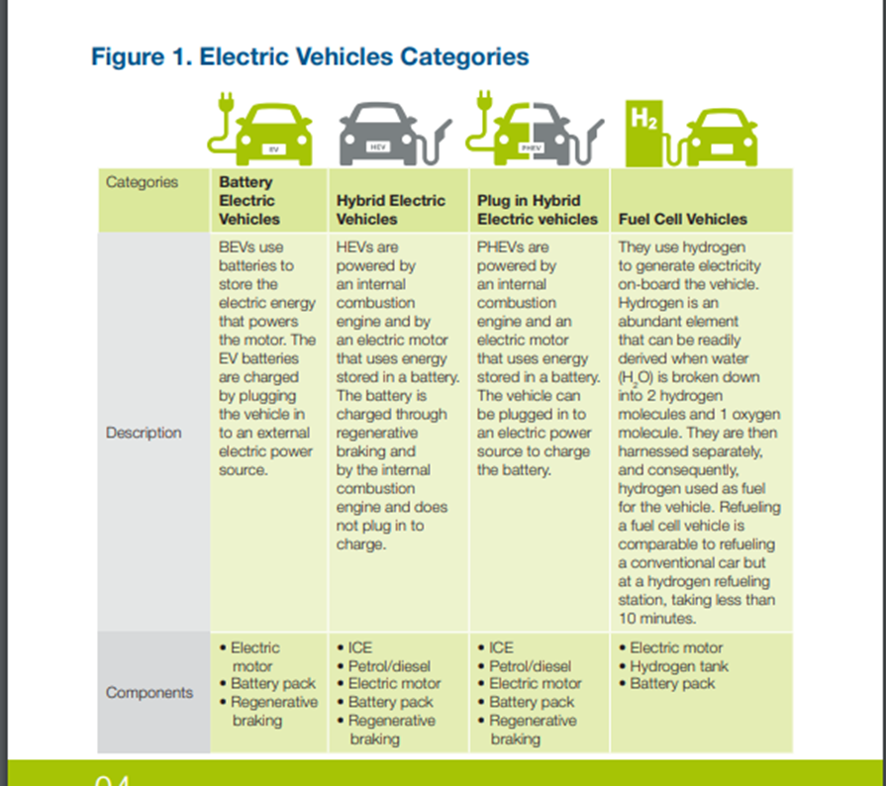

# Swapp Battery Swapping Network – Kiosks (Solar Paneled Roofs Ing Network

## Table 3 : Swapp Battery Demand

|  |  |
| --- | --- |
| Swapp Battery Demand | |
| 1) 2 Wheels electric motorcycle | As at 31stDecember 2017, therewere about 1,231,000Two Wheelers |
| 2) 3-Wheeler Cargo  3-Wheeler Passenger | 23,000Three Wheelers in Kenya, almost all of which are propelled by ICEs.(2  June 2018, Kenya had about 1.5 million 2 and 3 wheelers |
| 3) 3-Wheeler Passenger | It therefore follows that as at June 2018, Kenya had about 1.5 million 2 and 3 wheelers |
| Demand | Inorder to forecast the extra electricity demand for shifting to electric mobility, a hypothetical assumption that all the existing 1.5 million ICE propelled 2 and 3 wheelers in the country are replaced with electric ones. |
|  |  |

## Swapp Battery Swapping Network

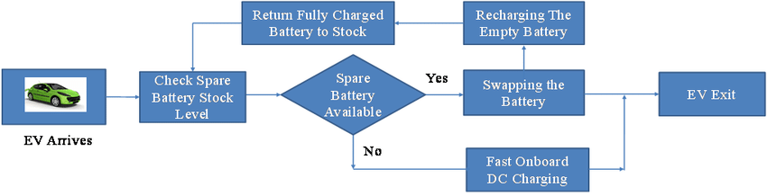

Figure 4 shows: Swapp Battery Swapping Network

## Electricity Demand for e-Mobility

Figure 4 shows: Electricity Demand for e-Mobility

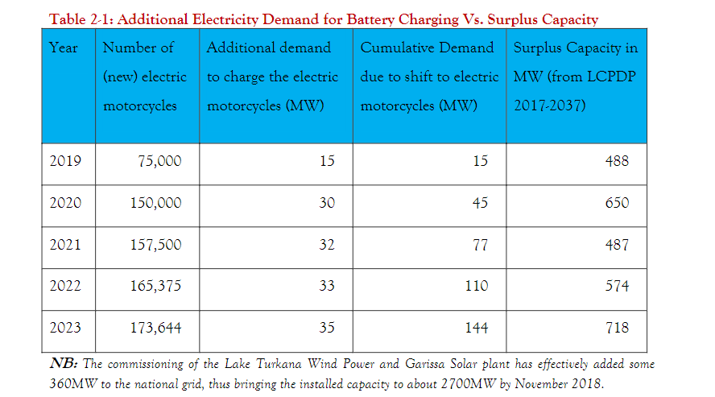

## Battery Swapping Network: Questions most asked

|  |  |
| --- | --- |
| Kenyan Profile | |
| 1) How do I charge my vehicle | * Charging an EV requires plugging it into a charger connected to the electric grid, also called Electric Vehicle Supply Equipment (EVSE). There are different categories of chargers, based on the maximum amount of power the charger provides to the battery from the grid. |
| 2)different categories of chargers | * Level 1: Provides charging through a 120V alternating current (AC) plug and does not require installation of additional charging equipment. Most often used in homes. * Level 2: Provides charging through a 240V (for residential) or 208V (for commercial) plug and requires installation of additional charging equipment. It is used in homes, office buildings, and for public stations. * DC Fast Charge: Provides a high-power Direct Current (DC) current generally up to 120kW directly to the battery and requires highly specialized, high-powered equipment as well as special equipment in the vehicle itself. * Some EVs, the battery can simply be removed and exchanged for a fully charged battery or taken home for charging. This equalizes the standard time of fuelling a conventional vehicle10 |
| 3) Where do I charge? | * Charging of EVs can be done at home, at the mall, at work or in public charging stations. Charging at home or work is possible via the standard electrical power points (240-volt AC/15 AMP) electricity supply. * DC fast charger outlets are installed in large residential and commercial buildings or along busy highways |
| Available charging options | * At the moment, there are fast chargers set up at the Hub, Two Rivers and Thika Road Malls in Nairobi by Nopia * The viability of charging through induction as an advanced technology is also being tested. It will eliminate long charging times as induction can also take place while the vehicle is in motion on the road |

# Contents

## Global trends

|  |  |
| --- | --- |
| Trend | Country |
|  | Kenya |
| Market | Kenya has crurent 3.2 million vehicles with 2&3 wheelers presenting the largest share of the vehicle fleet and holding the highest rate of motorization, with 108,000 motor cycles new registered in 2018 |
| ii. Pricing analysis | an internal combustion engine of a motorbike has 267 Wh/km,3l * 8.9kWh/l equals 27kwh/100kmand a total of 12% efficiency… based on field tests, electric enginesof e-motorbikes have < 25 Wh/kmper Person, 2.5 kwh/100km, and a total of >90% efficiency… that costs per litre petrol are ± 1€and costs per 100km are ± 3€… costs per kwh are ± 0.25€ and costs per 100km are ±0.75€… servicing and spare part costs of EVs are reduced to about 10% of original price level… electric engines save C02 emissions of about 2.32 kg CO₂/Lge per km, per bike at 4.5l per day (loaded) and annually around 3.777 t C0₂ per bike and year |

## E-mobility Development impact in the light of SDG (Sustainable Development Goals)

Figure 1 summary of E-mobility Development impact in the light of SDG (Sustainable Development Goals

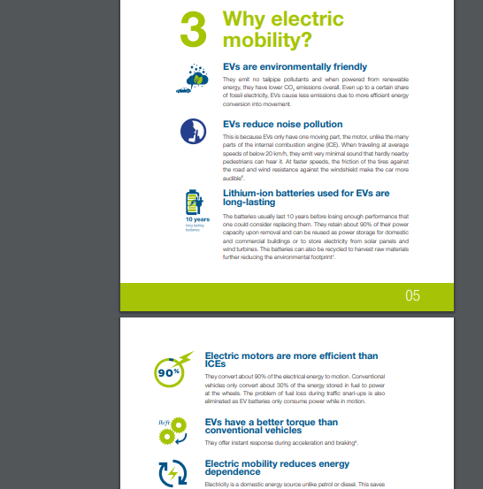

## Investment opportunities – (Financial options)

|  |  |  |  |  |
| --- | --- | --- | --- | --- |
| Country | Demand | Growth |  |  |
| Kenya | Kenya will import a projected  730,000 motorcycles until 2022 | Two- and three-wheelers are a central transport mode in many low and middle-income countries, including African ones, quickly rising in numbers to a 50 percent increase by 2050. | In 2022, China will decrease NEV subsidies by 30% and then stop subsidies in 2023. NEV refers to New Energy vehicles, virtually all are electric vehicles. | pan-African. asset financing company [M-KOPA](https://m-kopa.com/)  Reduction of excise duty20% to 10% |

## Market Overview

## Comparison with 1300cc less vehicles (new & used) (Taxation,

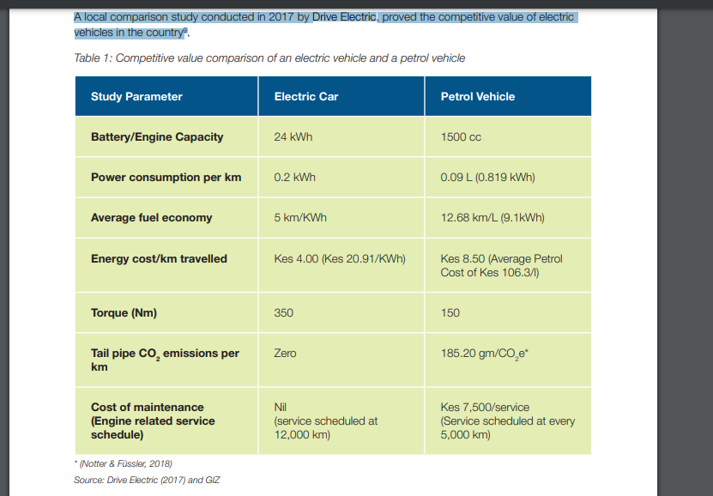

## E-mobility opportunities in Kenya

E-mobility is key in supporting the government’s commitment to transform the transport sector into allow-carbon, efficient and reliable system that will drive social and economic growth in the country—furthermore it presents a new business opportunity. The SDoT has made it a priority to create a nenabling environment for the development of the sector:

* Reduction of excise duty on electric vehicles: The Finance Bill of 2019 has proposed a reduction on the excise duty for all vehicles with only electric motor for propulsion (BEVs) from 20% to 10%21.
* Development of standards for electric vehicles: The Kenya Bureau of Standards has developed and adopted standards that apply to electric vehicles imported into the country. Up until now, a total of 24 standards have been developed and adopted, covering specifications and testing procedures for safety aspects as well as performance and power consumption elements22.
* Endorsement of private and development sector support

1. The government is involved in an e-mobility pilot with UN Environment where they will engage the City of Kisumu and Kenya Power & Lighting Company Limited through deployment of a total of 50 electric motorcycles on a pilot basis23.
2. The SIEMENS Stiftung Foundation is piloting electric trucks, cargo-bikes and boatsin Western Kenya through WE!Hub Victoria Ltd.
3. Through cooperation with GIZ, the State Department of Transport is: Creating the necessary policy environment and regulatory framework for the uptake of e-mobility
4. Developing awareness materials on the feasibility and advantages of e-mobility inthe country

* Kenya générâtes over 2700MW, out of which over 80% is renewable, against the demand at 1860MW13. The Excess 800MW coud be utilized to power an electric transport fleet. \
* The demand goes even lower to 1000MW during off-peak hours between 10pm and 6am; this is the ideal time for the slow charging at home. The electricity access rate in the country also stands at 73.4% as of the end of April 2018, but it is also possible through decentralized power inputs such as solar panels to power electric mobility in areas not connected to the national grid14.
* A global leapfrog to electric vehicles, already underway in countries like Norway and China, is essential to curb carbon dioxide emissions.
* Scaling up the transition to electric mobility will require investments in battery charging infrastructure. Kenya’s electric power generation capacity is sufficient to support the charging infrastructure. However, while demand for motorcycles is high, particularly in rural areas, distribution networks are inadequate. However, this challenge may be tackled by using solar energy, setting up charging stations, consulting boda-boda operators and using lithium ion batteries.
* UNEP’s Electric Mobility (eMob) Programme promotes the transition of low-income countries to zero emission vehicles, in line with the UN Environment Assembly’s Air Quality Resolution and the Paris Agreement.

# Country Economic Indicators

## Market Challenges

. These include high

* upfront investment costs in vehicles and infrastructure, as well as perceived lack of competitiveness with fossil fuel vehicles that constrain the uptake of e-mobility initiatives/
* Transport operators and their representative associations are less recognized as major players in the transition, far behind new e-mobility players (start-ups) and public authorities.
* Current gaps that need to be tackled by policymakers and stakeholders in order to implement inclusive electric mobility in East African cities, considering modalities that include transport providers and address their financial constraints.

# Business Model

## Business Model construcrs

Business Model: concerning the role of different stakeholders reveals that greater on-the-ground mobilization of various sectors is visible than the policy environment

incentives and barriers: a growing number of private stakeholders are looking at meeting the decarbonization needs identified by public authorities, international organizations, donors and NGOs, combined with air pollution reduction, while exploring potential benefits from the lower operational and maintenance costs of EVs.

financial and technical barriers: persists as high upfront investment costs in vehicles and infrastructure constraining the uptake of such private initiatives, combined with persisting interrogations on the capacity of EVs to provide similar uses, compared to current fossil fuel vehicles in terms of road conditions, carried weight, range and speeds.

environmental and economic drivers, as well as financial and technical hurdles for transport electrification, e-mobility in low- and middleincome countries [79], where affordability, total cost of ownership and performance are significant aspects

Regardless of these barriers, start-ups remain the most active actors in the field of e-mobility transitions, quite universally across the urban contexts.There is also a recognizable effort between start-ups and public sector officials to build coalitions towards mainstreaming of e-mobility.

For the former, these coalitions are crucial as they may allow them to remove obstacles and procedural difficulties they encounter along the way and Sustainability may open various business opportunities. The latter are incentivized by the fact that e-mobility can support them in reaching environmental goals defined within the policies they support, alongside economic goals (manufacturing, energy independence, economic growth) fitting in a perspective of “low-carbon development”].

conventional operators,:who might have an equally important role in the transitioning process, are still relatively marginalized in the formation of interest communities

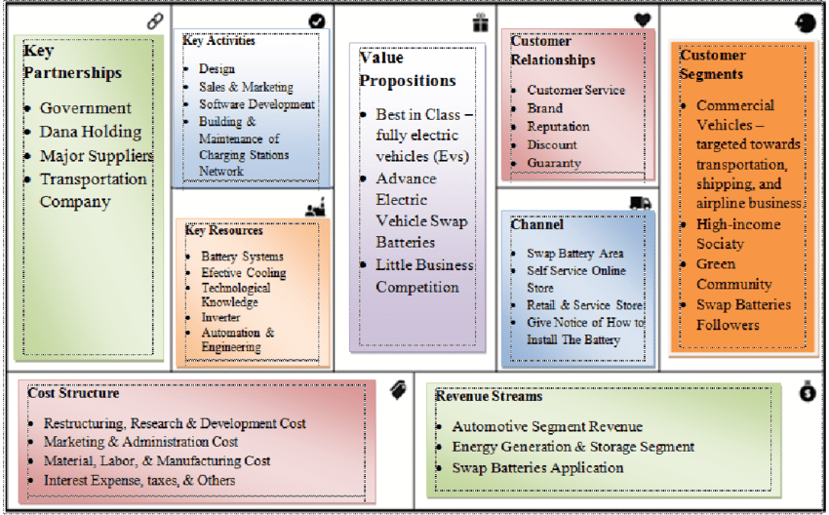

# Business Model

# Industry and Market Analysis

## Value Chain Analysis

* The conducted policy and project documentation analysis reveals that Kenya have initiated steps of a transition towards transport electrification, yet at different paces and taking diverging approaches in terms of sequential order(targets, policies, standards, incentives).
* Overall, they are still at an early stage of policy formulation, and detailed policies are still in the making. More advanced policies are anyplace and Kenyan contexts where electric vehicles are mentioned, particularly in various documents concentrating on environmental and climate policies, including documents such as the NDC or Climate Change Action Plan.
* There are some technical standardson e-vehicles recently introduced in Kenya .Similarly,in a more strategic approach concerning detailed mainstreaming methods ofe-mobility is included in a comprehensive feasibility study.
* Relatively weaker attention is given to e-mobility in city-level policies, which, except in Kisumu, only vaguely mentionthe phenomenon or are currently working towards eligible strategies.
  + 1. SWOT
    2. PESTEL

A PESTEL analysis summary highlights the in-depth evaluation of complex scenarios and external environment factors that postulate a foreign investment destination's political, economic, social, technological, environmental, and legal challenges. The evaluation will give PURE ahead starts a competitive advantage and diminish business failure due to unforeseeable macro shocks.

***Table 6: ii. PESTEL Pestel Analysis (Author,2021)***

|  |  |
| --- | --- |
| Factor | Description |
| Political environment in  Country-level  Policies | . Ongoing work on standard  Nairobi  National Climate Change Action Plan 2018–2022announcing EV technical standards, incentives ,pilot projects and public procurement ,implementing the 2020 updated NDC supporting low-carbon and efficient transportation systems  1. Ongoing revision of the Integrated National  Transport Policy (2009), including EVs  2. Target of 5% of imported electric cars annually  by 2025 (National Energy Efficiency and  Conservation Strategy)  3. Kenya Bureau of Standards (KEBS) 21 standards  for EVs in 2019  4. Financial Bill of 2019 reducing excise duty rates  for all battery electric vehicles  5. Exploratory work: e-mobility study, workshops,  works on taxation, registration and importation  of EVs |
| Economic | Nairobi − Climate Change Action plan in the making mentioning e-mobility  Consideration of one electric BRT corridor− Kisumu  Sustainable Urban MobilityPlan (SUMP)2020 setting  electrification targets |
| Social | Social trends (buying online training programs)  Demographics  Attitudes towards products, safety, and health |
| Technological  Incentives for  integration of  transport providers  in e-mobility | Absent at this stage − Absent at this stage − Absent at  this stage − Absent at this stag |
| Environmental Climate Change Policies | Climate Change Policies  AKenyan authorities have not quantified a similar overarching mitigation target viae-mobility yet; however, the National Climate Change Action Plan 2018–2022 announced aseries of measures facilitating the introduction of EVs and identified the opportunity toreduce 60% of two-wheeler emissions via a transition to electric motorcycles |
| Legal Challenges  Restrictive  regulatory measures  on conventional  vehicles | National level: age limit of 8 years to importsecond-hand cars − Age limit of10 years importing− City level: possibility for second-hand carslow-emission zones(2019 Nairobi City  County Transport Bill) |

* + 1. Porters Five Forces Analysis

### P5Fs(Porter five force)

Table 7: The PURE Porter's Five Force Analysis (Author,2021)

|  |  |
| --- | --- |
| Porter's five force | Description |
| Compétitive rivalry | Kenya |
| Bargaining power of suppliers | Buyers prefer to pay as little as possible for the best products  —buyer apathy achieved by low price offering hurting firm profitability.  Strong buying base with a higher bargaining power increasing discounts on large volumes. |
| Threat of substitutes | New offering higher product and service proposition lowering profitably.  Substitute products offer unique features, offering lower prices. |
| The threat of new entrants | New entrants bring novel technology, new processes, and products |

# SWOT Analysis Su

Table 10: PURE SWOT (Author,2021)

|  |  |
| --- | --- |
| Strengths | Weaknesses |
| Competency  Huge market;  Huge labor force  leverage the technology environment  Reduced Noise Pollution  Lower lifetime running costs than combustion engine vehicles  Current lack of charging infrastructure | Requires strong enabling policies,  including tax incentives and subsidies  Competing priorities for limited  government funding in Sub-Saharan  High initial investment costs upfront  compared to internal combustion  engine vehicles |
| Opportunities | Threats |
| Africa’s abundance of solar energy makes  Unfinished supply chains  PV charging stations the preferred choice  for rural EVs  Optimizing fleet mix by introducing smaller cheaper vehicles and focusing on 2&3  wheelers and light vehicles | risk of expropriation Interest rates  Covid-19  Envromental regualtions(paris agreemt 2016) (2016).  Rising raw material obil profitability.  Changing consumer buying behavior  infrastructure driven supply chain model.  isolationism in usgovernment thus  Operating environment often challenging  and disadvantageous with lack of enabling policies  Long recharging times and high costs  for batteries |

# Market Strategy (Local)

The pilot aims to help policy makers assess the barriers in uptake of the much-needed technological shift towards electric bikes, and to demonstrate that the shift is feasible and within reach. In Kenya, the number of newly registered motorcycles, commonly used as taxis (boda-boda), was estimated in 2018 at 1.5 million and will likely grow over five million by 2030. Though developing countries have the fastest growing fleets of bikes, most lack vehicle emissions standards or programmes and incentives to promote zero emission vehicles.

3 Year Strategy Plan

Based on the need to remodel business matrix,the following facets of the proposed 3year Strategy Plan (locations, resources, technology and high level Income & Expenditure forecast) shall be explored. The proposed Model thus should be able to catch all those parameters to reflect a reingorated framework as shown in figure 12

## : Market Demand

## Competitive analysais

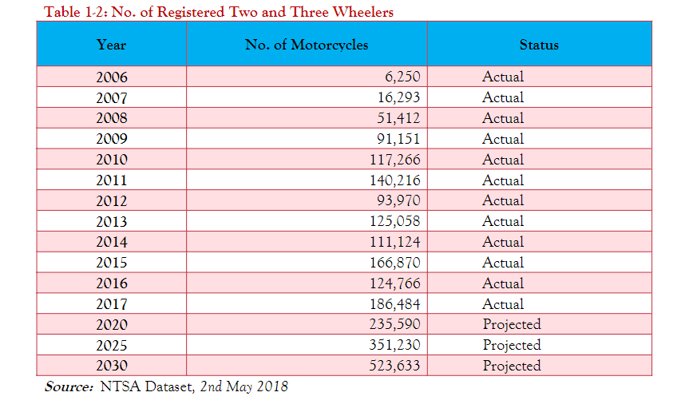

Competitive analysis

## Do we have electric motor vehicles in Kenya?

Nopia Ride is the first fully electric ride sharing app established in August 2018. Hailed as an ‘eco-taxi’, it offers zero-emission rides allowing the company to charge less compared to other ride hailing apps, pay their drivers more and protect the environment. The company is truly competitive in the market as drivers do not pay for fuel, enabling them to make more than their competitors. The company is scaling up, building three charging stations at Two Rivers Mall, The Hub and Thika Road Mall. Opibus is a Nairobibased green energy company that deals with electric vehicle conversion. Its initial focus has been on conversion of off-road vehicles, for safari use. They are also developing an electric motorcycle through their subsidiary Flux Motors18. Solar E-Cycles develops electric bicycles, scooters and 3- and 4-wheel vehicles. The solar powered light electric vehicles can travel 50 km a day just with power from the solar rooftop. The three wheelers can serve as replacement for tuktuks (auto rickshaw) which are popular in urban areas for short distances. The inexpensive solar car can serve as a sustainable economic development tool in isolated off-grid rural areas in Africa19. Drive Electric offers services such as charging station installation, operation and maintenance, e-mobility consultancy, electric vehicle leasing and fleet a

### Marketing strategy

Kemppaine (2015) asserts that Marketing segmentation is different from mass marketing. Marketing segmentation is not indiscriminate but leverages specific market niche aspects and processes such as segmentation, targeting, and positioning by aligning products and services to particular markets, intentionally subdividing the mass markets into controllable submarkets.

Marketing segmentation plan

T

|  |  |
| --- | --- |
| ' Value Proposition Through segmentation And Targeting. |  |

|  |  |  |  |
| --- | --- | --- | --- |
| Segment | Segmentation Dynamics | Product /Service | Reason |
| Geographic Segmentation | Pure ' Divides The Potential Markets Into Distinct Regions |  |  |
| Benefit Segmentation | Benefits And Capabilities Of Product Or Service |  |  |
| Volume Segmentation | Volume Based Metric (Sales Volume) |  | 80/ |
| Behavioral Targeting | Target Increasingly Smaller Segments Within Bigger Segments (Narrow Casting) |  |  |

### 

### Customer Segmentation

Customer segmentation Marketing, a relatively new concept in marketing, has been

Cities’ Profiles—Kigali, Nairobi, Kisumu and Dar es Salaam The four cities included in this study are dynamically developing commercial and cultural centers located in Eastern Africa. Nairobi, Dar es Salaam and Kigali are the biggest cities and urban agglomerations of their countries, inhabited, respectively, by 4.4 [20], 6.4 [21] and 1.29 [22] million people. Kisumu is the third biggest city in Kenya with an urban population estimated at 567,963 and a county population of 1.1 million inhabitants. While differing in size, geographic context and specific functions, they share commonalities in terms of the urban transformation processes they undergo. Additionally, the cities experienced stable to rapid population growth (Kisumu on average by 1.63% in the years 2000–2015 [23], Nairobi—3.8%, Dar Es Salaam—5.4%, and Kigali—4.2% on average in the years 2000–2018 [21]). A large proportion of this growth is concentrated in informal settlements, emerging in a peri-urban context in most of them. For instance, 62% of Kisumu’s inhabitants are estimated to live in informal settlements.

### 

### Integrated Marketing Strategy

### Online Marketing Plan

### Product and product differentiation

### Channel Strategy

### Brand

### Branding

### Budgeting

### Revenues

### Sales

### Profitability analysis.

.

### Valuation:

.

### Pricing Strategy

Floyd Owino

Student at Sori secondary school, spends 30KES ($0.30)for a e-bike ride to school; regularly rents e-bike fromWeTu Hub at a daily rate of 300KES ($3)

Goretty AkothMarket trader selling groceries, daily income

of 2000 KES ($20) with a profit margin of

500 KES ($5)

George Omodi

Boda Boda Taxi Driver, 30 years with a family of four,

owns bicycle, works 7hrs/day and travels 4km/day with

a daily income of 800KES ($8) with profit margin of

500KES ($5)

|  |  |  |  |
| --- | --- | --- | --- |
| Pricing Construct | Potential Elements | Product | Price Per UNIT FORMULA |
| Competition | No Of Competitors  Market Share  Degree Of Differentiation |  | * Replacement Cost * Market Comparison * Net Present Value * Value Comparison |
| Condition | Existing Business Laws  Prevailing Economic Conditions  Inflation  Interest Rates |  | • Replacement Cost  • Market Comparison  • Net Present Value  • Value Comparison |
| Customers  women  men  teens | Brand Allegiance  Proximity To Customer | Others | • Replacement Cost  • Market Comparison  • Net Present Value  • Value Comparison |
| Capacity | Lead Time  Product Availability |  | • Replacement Cost  • Market Comparison  • Net Present Value  • Value Comparison |
| Costs  Marketing costs | Fixed Costs  Variable Costs |  | • Replacement Cost  • Market Comparison  • Net Present Value  • Value Comparison |

PURE Long term Marcom plan

|  |  |  |  |
| --- | --- | --- | --- |
| Product and service portfolio | | | |
| focal points | Strategic recommendations | Strategic recommendations | Strategic recommendations |
| inMarket Analysis | Macro and micro, firm | Competitive analysis | Pestel, P5 Swot,vrio |
| Canvas strategy | Brand positioning  Brand loyalty  brand status  Brand presence  Segmentation  Communication | Value Proposition | Growth, dominance, strategic |
| Channels | Marketing mediums  Direct selling  Indirect strategy  Interactive marketing | Marketing mediums | Facebook  Twitter  Instagram  Websites  Influencers |
| Objectives  Product and service portfolio strategies | Option 1 | Allocation |  |
| Option 2 |  | Growth, dominance |
| Market Development  Brand positioning  Brand loyalty  brand status  Brand presence | Option 3 |  | Growth, dominance  positioning product service demand  shortening sale cycles |
|
| Product diversification. | | |  |
| Product development and diversification | Option 5 | The |  |
| Diversification | Option 6 | . |  |
| Feedback |  |  | Ansoff,Situaton Audit etc |

## Supply and Demand

## Environmental impact

The CO2emissions from motorcycles per km are about one third that of LDV and this is primarily because of their better fuel economy. However, they emit other more potent greenhouse gases which include up to 16 times Hydrocarbons, 3 times more Carbon Monoxide and 4 times more NOxcompared to that of LDVs(Ana-Marija,2006).The significance of this is that disproportionately high amount of other pollutants are emitted bymotorcycles other than by cars

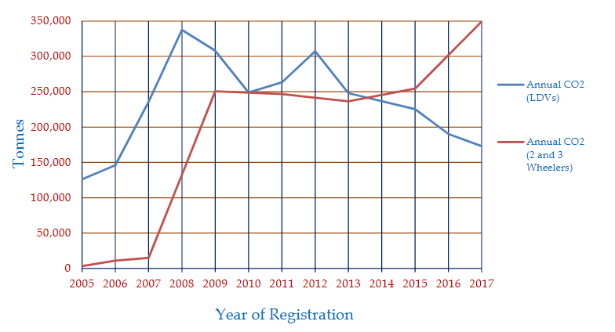

# Conclusion

The adoption of electric powered vehicles will reduce the levels of noise pollution, air pollution, GHG emissions and overall expenditure on oil imports for the country while creating a more climate-friendly environment. A shift to electric mobility will also lead to creation of employment; directly and indirectly in the automotive, electronics and IT industries as well as in other industries such as in the deployment and operation of charging infrastructure, local assembly and maintenance of EVs and recycling or reuse of the battery at the battery’s end of life. There is therefore need for capacity building through training on development, deployment and maintenance of e-mobility infrastructure. A study by the European Association of Electrical Contractors shows that more than twice as many jobs are created in the electricity value chain as are lost in automotive manufacturing. The study concludes that by 2030 a total of nearly one million permanent jobs could be created globally in fields such as electricity generation, civil and road works, battery cell manufacturing, installation and maintenance. These are high quality, local, green jobs16.